NDIS Market Approach
  - Statement of Opportunity and Intent
November 2016

Contents
1 Highlights 3
2 What is the purpose of this Market Approach? 4
2.1 Vision of market stewardship role 4
2.2 Structure of document 5
2.3 What is a market steward? 6
2.4 What are the opportunities of this new NDIS marketplace? 6
2.5 Evidence from trial sites 9
2.6 Why is there a need for market stewardship? 10
2.7 What is the impact of the NDIS marketplace for disability providers? 12
2.8 What is the long term vision of the NDIS marketplace? 13
2.9 Key features of this long term vision 14
Participants as consumers 14
Competition 14
Data driven markets 15
Sub-markets 15
Insurance Principles 15
Weak/thin markets 15
A market beyond 460,000 (NDIS funded) disability consumers 16
3 NDIA’s Market Stewardship Functions 17
3.1 NDIS Market Stewardship Transition Roles and Responsibilities 17
Roles and responsibilities in market stewardship and oversight 18
3.2 NDIA Market Approaches: Market Intervention Strategy 20
Market commissioning principles 21
Market intervention options 23
Commissioning a service 26
4 Next Steps – Navigating growth to full Scheme 28
4.1 2016-17 Forecast Market Stewardship activities and projects 28
What does the market look like? 28
What Stewardship Activity will the NDIA do? 28
4.2 2017-18 Forecast Market Stewardship activities and projects 30
What does the market look like? 30
What Stewardship Activity will the NDIA do? 30
4.3 2018-19 Forecast Market Stewardship activities and project 31
What does the market look like? 31
What Stewardship Activity will the NDIA do? 31

1 Highlights
The National Disability Insurance Scheme (Scheme, NDIS) is a transformational approach to disability supports and services that is creating a radically new disability marketplace over a three-year transitional period and beyond.
The NDIS – the largest social reform since Medicare – is being implemented at a rapid rate when compared with the introduction of national competition policy reform, employment service reform, and utility reform.
The new marketplace will take time to mature and the National Disability Insurance Agency (Agency, NDIA) with the Commonwealth, state and territory governments will jointly oversee the establishment and growth of the new NDIS disability marketplace to ensure Scheme objectives are realised.
The challenge and opportunity over the immediate three-year transitional period is: (1) a fundamental shift, disrupting existing operating models, from a welfare to a market based system where people with disability can choose their supports through individualised commissioning; (2) an increase of funding in the sector from $8 billion per year to $22 billion per year; and, (3) an increase in the number of participant-consumers from just over 30,000 at the end of trial at 30 June 2016 to approximately 460,000 by the end of 2019-20. The Scheme creates significant opportunities for existing and new providers who can successfully engage with participants as customers, understand the NDIS requirements for outcomes, and provide value for money. This recognises that our engagement, analysis and strategies will need to be responsive to many different circumstances.
The Agency’s role in this marketplace will vary from being light touch, such as providing information to the market, to empowering local community driven, social enterprise based bespoke solutions, to more interventionist such as market commissioning (in limited circumstances) of supports or services where there are market gaps or significant risks.
During the transition period, and to facilitate a timely and meaningful growth in supply in the new marketplace, the Agency expects to play a more active role as the marketplace adjusts and grows. It will take time for consumers to confidently exercise their market power, for existing providers to expand, for new providers to enter and for the disability workforce to grow.
Over time, a vibrant, multifaceted, open and competitive marketplace will operate sustainably to deliver the needs of individuals and is a key foundation of scheme sustainability and value.
Evidence from trial sites and initial market signs have thus far have been positive, but the Agency is aware that this new marketplace presents short term challenges, and that few markets of this scale in Australia have ever developed and grown in such a short time.
The Agency’s market stewardship role will therefore require monitoring, evaluation, oversight and where necessary, support and intervention, in pursuit of a sustainable and successful NDIS.

2 What is the purpose of this Market Approach?
The purpose of this document is to set out the role of the NDIA as a market steward, in the new disability marketplace during the three year transition phase to full Scheme in 2019-20. By doing so the Agency is seeking to provide greater certainty for existing providers and potential new entrants as they assess opportunities the NDIS brings and to serve participants within the NDIS.
The NDIS marketplace is divided into submarkets of different supports, services and areas. Where the Agency identifies that one of these submarkets lacks supply, competition or informed consumer choice it may choose, in the interest of participant outcomes to exercise a function it has as a market steward to achieve the Scheme’s objectives and in the interest of participants.
This is part of the insurance principles which underpin the Scheme, and the Agencies role in managing the sustainability of the NDIS. As a market steward the Agency along with the Commonwealth, state and territory governments has oversight of the development of the NDIS marketplace.
The document describes the NDIS Market approach a high level and is designed to:
ensure that the NDIS community understands the roles and responsibilities the Agency has in this new disability marketplace;
build confidence in the marketplace;
ensure accountability for the Agency; and,
create predictability about how this newly developing marketplace will operate.

2.1 Vision of market stewardship role
This vision for the NDIS and aim of market stewardship is to create an efficient and sustainable marketplace through a diverse and competitive range of suppliers who are able to meet the structural changes created by a consumer driven market. More specifically this involves:
enabling existing and emerging suppliers to mature at an appropriate and sustainable rate;
providing an environment for innovation in planning and delivery of supports; and,
building strong business integrity systems and processes and capability.
The extent and type of intervention required depends on the shape and maturity of the NDIS marketplace. The Agency recognises that it will be necessary to play a more active role during the transition period (2016-19), but this role will lessen over time as the market infrastructure matures, suppliers respond to the NDIS operating model, and as levels of demand grow and consumers are better equipped to exercise choice and control.
As part of this market approach the Agency acknowledges the need to embrace a broad diversity of supply solutions. It is expected that the future NDIS marketplace will comprise of traditional supply, through commercially orientated for-profit and not-for profit organisations as well as alternative business models (which are bespoke and community generated) that are driven by the values of the Scheme and fulfilling the needs of people with disabilities. By encouraging these types of alternative business models, the Agency seeks to generate viable employment and business solutions for people with disability and to retain the concept of participants owning and driving their own solutions.
This Market Approach is focused on transition. The Agency recognises that the marketplace will take time to develop, and that further iterations of this strategy will be required as the Scheme evolves and post 2019-20. The marketplace itself will play the key role, especially in the long term, of providing genuine choice for eligible people with disability.
Diagram 1: Relationship of this Market Approach to other NDIS strategies
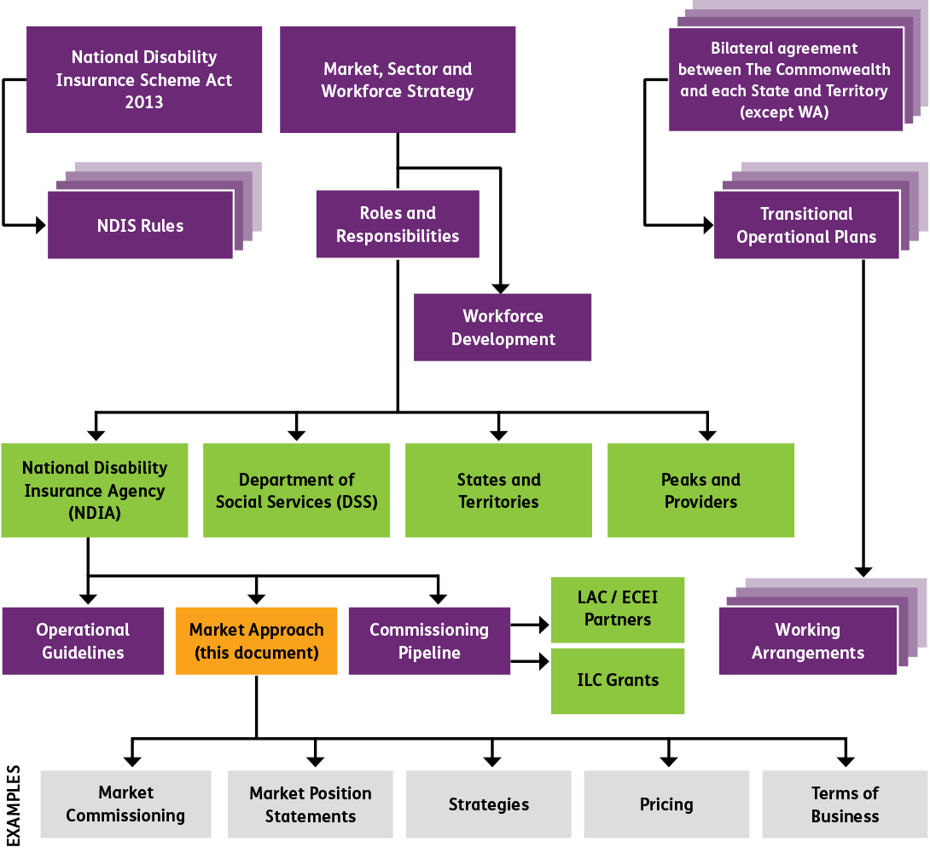

2.2 Structure of document
The document has three parts:
Setting out the rationale for the Agency’s market stewardship role, highlighting the importance of this role during transition;
Explaining the range of stewardship functions that the Agency can take during transition to facilitate an efficient and stable marketplace with properly functioning submarkets; and,
Outlining what providers can expect from the Agency over the transition phase as the Agency assists in the growth and maturation of the marketplace.

2.3 What is a market steward?
Market stewardship recognises that when governments implement policies to increase consumer choice and adopt market based delivery, they must also oversee how the marketplace develops. Typically where information is insufficient or unevenly available, transaction costs too high, choice unable to be informed by quality as well as price demand is “thin”, inputs such as workforce are constrained. If the marketplace is not working as intended a responsible market steward identifies what action, if any, it should take to improve the marketplace so policy objectives can be realised.
There are a number of functions that a market steward can use to improve the marketplace:
Monitoring: observing the NDIS marketplace and assessing whether it is achieving its outcomes. This will be greatly informed by the data being collected through day-to-day operation of the Scheme, which will increasingly use longitudinal data to understand market gaps, market/provider efficacy and to develop responses.
Facilitating: actions that directly influence demand in the NDIS marketplace and indirect actions to improve the functioning of the NDIS marketplace. This includes providing information, setting prices, and developing systems/infrastructure to support market transactions. In addition, facilitating supports diversity of supplier business models.
Commissioning: direct sourcing of supports or establishment of preferred provider arrangements supported by controls and “rules” that must be complied with to participate in the NDIS marketplace.
The Agency has already undertaken a number of market steward functions during the trial phase of the Scheme and in preparation for launch. It will continue to undertake an active role during the transition to full Scheme over the next three years in the pursuit of the interests of participants and an efficient and sustainable marketplace in the short, medium and long term.

2.4 What are the opportunities of this new NDIS marketplace?
The NDIS is not another government-controlled social welfare scheme. It is underpinned by a new national consumer-controlled marketplace with enormous growth potential. It is based upon individual commissioning, where eligible people with disability can use their NDIS plans to choose those supports and services that best help them achieve their specific life goals.
This individually commissioned market for disability services harnesses the power of the market to achieve better outcomes for people with disability.
The disability marketplace being introduced over the next three years is radically different from the previous system where government funding arrangements with the disability sector have been programmatic, predominantly in the form of block funding from government to disability providers. At the same time the market is not predicated on government procurement of not-for-profit NGOs. Services will be delivered by those organisations that consumers believe best meet their individual needs and preferences. To enable participants to have real choice, service offerings must reflect the diversity of people with disability, who may have specific needs, priorities and perspectives based on their personal circumstances, including the type and level of support required, education, gender, age, sexuality, and ethnic or cultural background.
This creates clear incentives for growth, expansion and entrance by new organisations. The Scheme is also on a scale not previously contemplated in Australia and is designed to address un-met need. Both funding and volumes of people participating in the marketplace increase dramatically. Funding of the disability sector will increase from over $8 billion per year to $22 billion per year by 2019-20; a more than doubling of funding for supports in three years.
It is important to note that there are a number of key issues affecting the market context within which the NDIS marketplace operates, particularly in transition to full scheme:
large parts of the marketplace are subject to in-kind arrangements and therefore, not immediately available to prospective providers;
there is a broader market of suppliers, beyond providers registered with the Agency (given self-managed participants are able to use registered and non-registered providers as they see fit);
NDIS is predicated on a market much broader than the current specialist disability marketplace including deeper community inclusion through local government, neighbourhood centres, recreational arts centres; and
people with disability who receive individually funded packages under the NDIS are not the only people that will require disability support services.
Diagram 2: Big demand growth brings opportunities and challenges
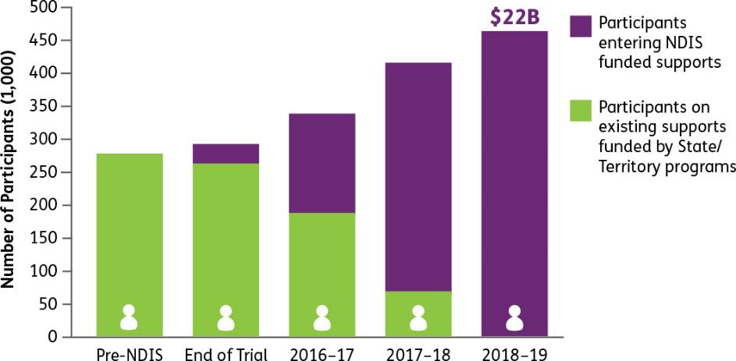
As at 2015-16 there were approximately 30,000 participants in the Scheme (seven per cent of the entire Scheme). This is expected to grow to 260,000 participants (57 per cent of Scheme) in 2017-18, 438,000 participants (96 per cent of Scheme) in 2018-19 and 458,000 participants (100 per cent of Scheme) in 2019-20 assuming all bilateral estimates are achieved.
Diagram 3: Projected Growth in NDIS participation
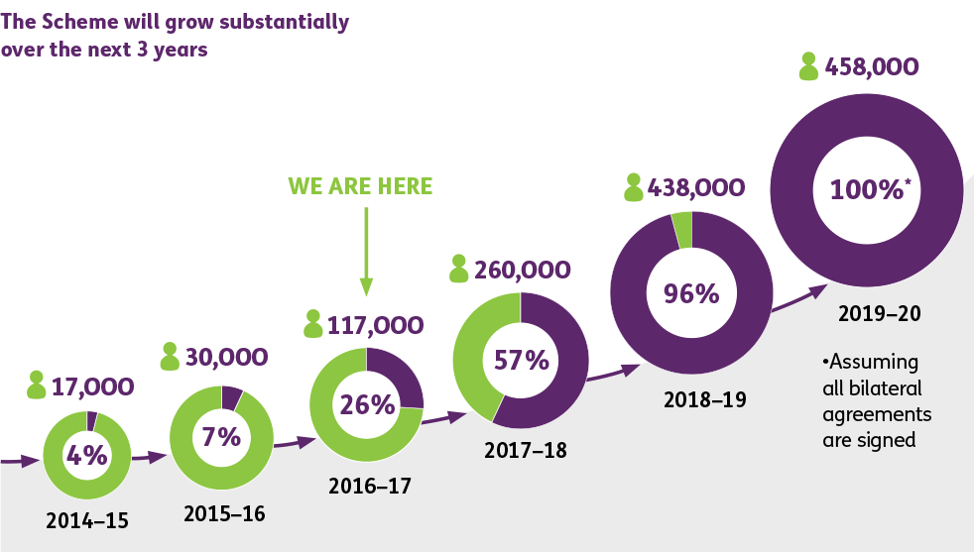
In the first year, to meet projected Scheme demand, growth in supply needs to be around eight per cent. By the second and third year respectively, growth must reach 30-40 per cent, although, as described in more detail in the Market Position Statements published to date, the supply needed to meet funded participant demand varies depending on location.
New South Wales is an illustrative example of the opportunity the NDIS marketplace creates. By 2019-20 NSW will be the largest market with about 140,000 NDIS participants. This is almost double the number of people with disability who are currently receiving funded supports under the national disability agreement. In dollar terms, the NSW market will double, growing from approximately $3.4 billion to $6.8 billion in the next three years.
Under this new market-based system, both prospective and existing providers of disability supports and services have lower barriers to entry and are no longer subject to government purchasing for (direct) funding. Instead they can focus on the value proposition they provide for their customers and the extent to which they are supporting the goals and aspirations participants have in their individual NDIS plans. In considering the value proposition brought to participants, providers must recognise that services delivered are to improve outcomes for participants and that in some cases, participants exercising choice and expressing demand will be limited, particularly during transition to full Scheme.
New opportunities will emerge for both non-profit and charitable organisations as well as for-profit and other new entrants from adjacent markets, digital disruptors, mainstream and offshore organisations.
The NDIS creates opportunities for existing disability service providers. The NDIS marketplace encourages growth and expansion for existing providers. Funding is not rationed between providers and organisational growth is limited only by the ability of organisations to meet consumer demand and needs. The marketplace will benefit from the brand recognition, options to innovate and wealth of experience existing NGOs have in the sector, including their relationships with their clients and relevant peak bodies and advocacy groups. Consumers will identify which organisations best meet their needs and market share will follow accordingly.
There are also clear market incentives for new entrants. Businesses outside the sector, especially from sectors that provide similar supports such as health and aged care will bring their experience and learnings into the disability marketplace in many cases for the first time. Innovative technology suppliers will also enter, with the expectation of the planned $1 billion per annum within the Scheme to be spent on assistive technology. As a market steward, the Agency has a role in transition to seek to mitigate high costs to enter the marketplace, participant switching costs and the imbalance of market information and knowledge.
Organisations wanting to win a share of this new marketplace will need to be competitive and efficient, but more importantly they will need to attract and retain consumers and demonstrate a clearly articulated value proposition to the participant as a priority including consideration of value for money for the participant.

2.5 Evidence from trial sites
There is evidence of the marketplace growing and responding in trial sites. As at 30 June 2016 there were over 3,500 registered providers in the NDIS, representing a growing range of supplier business types and service models. The NDIS has also triggered growth for sole traders and Small Medium Enterprises (SMEs). Across Australia, new providers have also emerged in NDIS trial sites to fill gaps in the market, for example delivering new community participation offerings to young people in areas where supports have not historically been located. The business types have been diverse as well including adjacent sector businesses such as fitness, sport, financial services, ICT, trades and builders.
In a trial site, an enterprising family business has taken advantage of the NDIS opportunity by leveraging their existing mechanics business, entering the market as a provider of Assistive Technology, continence supplies and now bridging into other supports as consumers demand. This has seen their business grow, creating local employment opportunities in the region.
Diagram 4: Projected NDIS expenditure compared with selected Australian Government programs (2019–20)
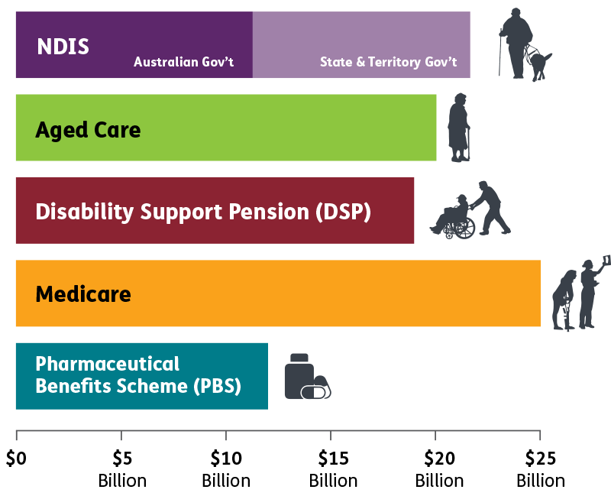
Adapted from the Department of Parliamentary Services, Parliamentary Library, Research Paper, The National Disability Insurance Scheme: a quick guide, 1 September 2016
As shown in the diagram above, the NDIS will be a significant market within the overall Australian economy and is larger still if the disability services not directly funded by the NDIS are included. Expenditure will exceed expected Commonwealth expenditure on Aged Care and almost double what is expected to be spent on the Pharmaceutical Benefits Scheme.

2.6 Why is there a need for market stewardship?
It is important for the Agency to maximise the benefits of this market based approach from the beginning of the Scheme.
The marketplace will take some time to work as it is intended for the Scheme and therefore the Agency has a role to play in improving the functioning of the marketplace, so the Scheme can achieve its objectives. In particular, the Agency will need to balance a large and rapid increase in demand (with potential upwards pressure on prices) against the overall financial sustainability of the Scheme.
Most critically, the NDIS requires a significant supply response within a relatively short timeframe. Supply of supports and services must double by 2019-20 to meet funded demand.
The NDIS is also being implemented at a much more rapid rate compared with other reforms such as national competition policy, employment services in Australia, utility reform and disability services in New Zealand. In only three years, the disability sector will:
undergo the major shift from a welfare based system where government funds suppliers, to a market based system where government funds eligible people with disability to choose their disability supports and services;
see a more than doubling of funding to $22 billion; and
replace a system that the Productivity Commission described as fragmented and underfunded with critical market areas underserviced.
International experiences where government has moved social and other services towards market-led service delivery show that who the market steward is, and the functions that are to be performed by the market steward, are often not clearly defined.
Tentative, reluctant approaches to market stewardship, would exacerbate the risk of the market not meeting medium and longer term outcomes of the Scheme and could undermine Scheme sustainability. In four UK social services areas where reform has taken place – secondary education, aged care, employment services and probation – issues arose due to a poor direction around who the market steward/s were and what their functions were to be. This led to poorer market service delivery that compromised the intended policy outcomes.
Developing a strong, contestable marketplace for disability supports is a long term project. All stakeholders in the marketplace will require time to build capability, confidence and systems to support the market mechanisms. Participants, possessing greater consumer power, are learning to make choices and explore different service options. Providers are building an understanding of their customer base and preferences, positioning service offers and transforming their operations.
Existing providers need to adapt their business models to a contestable marketplace. They will need to operate efficiently without direct government procurement, and in a way that is attractive to consumers.
Potential new providers emerging from other sectors such as health and aged care will bring with them experience in operating under contestable markets but will need to learn how to harness relevant disability experience and knowledge and apply it as they enter this new Scheme.
The Agency recognises that achieving the required levels of supply in the transitioning period cannot solely rely upon the marketplace responding, but the market will play an important role in meeting the increase in demand.
The Agency, as a market steward during the transition period will work locally and across the Scheme, to minimise market failures, information gaps, and perceived regulatory risks. These occurrences in the emerging marketplace would limit consumer choice and the achievement of the key outcomes of the Scheme. This means that in the short term the Agency will have a more active role in facilitating markets to ensure there is sufficient as well as innovative supply for participants.
As set out in the 2016-2021 Corporate Plan of the Agency, building a vibrant and competitive Scheme marketplace (and submarkets) comprising informed and active consumers and innovative competitive suppliers requires:
facilitating the provision of reliable and accessible information;
undertaking activities to accelerate market supply responses;
identifying and managing short-term market risks;
creating an environment in which innovation in technology will thrive around the Agency;
engaging with existing and potential new providers, and understanding the barriers they face transitioning to the Scheme; and,
establishing Agency processes, capability and systems to enable its role as market steward. (p.16)

2.7 What is the impact of the NDIS marketplace for disability providers?
Moving the sector from where it currently stands to the mature vision of the NDIS will take time.
The NDIA values the role of providers and sees them as a critical part of the NDIS as they will be delivering high quality, person centred supports to help participants achieve their outcomes. The NDIA would like to see a marketplace with a diverse array of providers that maximises choice and control for participants but also enables strong links with non-specialist services and family and community support to help achieve the overall NDIS aspirations of increased social and economic participation for people with disability.
The Agency is aware that this new Scheme has significant implications for the existing disability sector and for service providers both new and incumbent. This includes:
the opportunity to apply new ways of thinking in supporting people with a disability, and in most cases, transition to person-centred NDIS service delivery models, although some bulk-funded services will continue under other programs;
competing in a retail or commercial model, as people with a disability, or their agents, can ‘shop’ around for the service providers that best met their support needs, subject to the resources specified in people’s support packages;
providers managing competitive and investment risks in the way most businesses do;
introducing new and modified business processes including structures around marketing and advertising, financial systems, IT systems, record management, and quality control, as well as new processes around pricing, performance, governance, privacy, and compliance; and
people with a disability will have the opportunity to use non-specialist and niche services, making high quality performance by specialist agencies a key point of differentiation.

2.8 What is the long term vision of the NDIS marketplace?
The vision of the NDIS marketplace is to ensure that people with disability exercise choice and control and have access to a full range of quality services and supports.
This vision centres on the NDIS delivering its central objective: for people with disability to achieve their life goals, through the best available resources. Key outcomes for participants include overall increased independence with greater participation in employment, the economy, and community life.
The NDIA, like consumers, is seeking a marketplace with a diverse array of providers that maximises choice and control for participants, but also enables strong links with non-specialist services and family and community support to help achieve the overall NDIS aims of increased social and economic participation for people with disability. Choice will be fostered through harnessing a broad and interactive NDIS marketplace and community.
Diagram 5 (below) is a simplified illustration of how the NDIA seeks to promote balanced market growth by investing in the key components of the market and thinking actively about how the most open and inclusive (and powerful) market can be created.
There are three elements of the NDIS marketplace that need to be performing in order for it to function well, being demand, supply and intermediaries and infrastructure.
To ensure all stakeholder groups can and are incentivised to engage and purchase or deliver quality value-for-money services in the NDIS, there is a need to invest in them.
Strategies that focus only on supply but do not support and incentivise participants to build their confidence and capacity as consumers will not deliver the beneficial market effects underpinning the Scheme’s design.
Similarly, participants need structures to support them to find, negotiate and manage supports easily and fairly.
Many participants can and want to use “regular” services, so the design of the NDIS must take into account the purchasing power of participants as part of a broader cohort of consumers who need similar services. To focus only on specialised supports would not be consistent with the role of the NDIS to encourage the inclusion of people with disability in the mainstream of Australian society.
Diagram 5: Choice will be achieved through broad NDIS marketplace and community
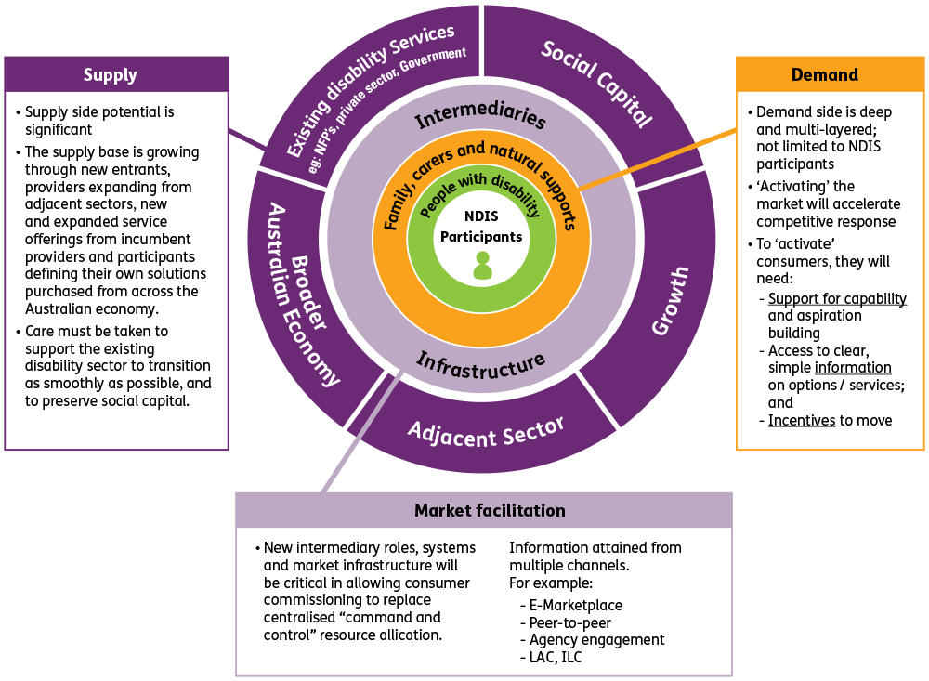

2.9 Key features of this long term vision

Participants as consumers
In the NDIS marketplace, people with disability are consumers. Under the previous system participants had little control over what happened to them and had limited choice of service providers. This overprotectiveness has been removed with the introduction of this consumer disability choice model. This is also balanced against the need to minimise potential conflicts of interest where many consumers may have less market power or face greater risks. Conflicts of interest rules have already been established by the Agency and will evolve over time and beyond transition.

Competition
Providers need to supply competitive products and services to NDIS participants. This will lead to more efficiency, greater quality supports and services and a reduction in prices once the market has matured. NDIS objectives are in line with the Harper review into Competition Policy which recommended that government-funded human services should be consumer directed as this would drive significant improvements in efficiency and effectiveness.

Data driven markets
The Agency has designed and established extensive and robust data systems for monitoring and understanding the marketplace and expects these will be enhanced further over time. By the end of 2019-20, it is expected that the Agency will have data from 460,000 participants and their purchasing of supports and services, providing Australia with the richest data on disability and a disability marketplace anywhere in the world. Other market initiatives such as Provider Benchmarking and the NDIS eMarket will provide further data to drive market decisions.

Sub-markets
The NDIS marketplace is characterised as a number of discrete ‘submarkets’ across the country in geographical location and support category. Different approaches may be needed for each, including for matching supply and demand. The NDIA is committed to providing clear information about where it considers the local or submarket dynamics require a variation to the usual approach or rules, and why. An example of this is the action taken by the NDIA to extend existing State and Territory school bus service provision for most of transition, on the basis that the disruption to families and providers from an overnight switch to individualised transacting was not fair or feasible, and to secure time to better assess need and plan an appropriate NDIS response. Likewise, the commissioning of the NDIA’s partners in the community has included clear guidance on rules and expectations about separation of roles whilst including provision for exceptions.

Insurance Principles
The NDIS is underpinned by insurance principles that make an investment in disability for the benefit of all Australians. As an insurance scheme, the NDIS takes a lifetime approach to a participant’s support needs and life goals. This represents early investment in people with disability to improve their outcomes later in life. Demand for supports will be closely monitored as a part of the schemes actuarial monitoring - comparing participant plans against typical support packages and tracking committed supports by participant characteristics and over time. This will ensure the ongoing sustainability of the provision of reasonable and necessary supports.
At the same time, to ensure the Scheme is sustainable, capacity building and capital supports bring with them an expectation of specific outcomes. Participants will be supported, and in some cases funding or other rules will be applied, to ensure these supports are founded on evidence and delivering on the expected outcomes.
Further insight on the NDIS insurance principles is contained in Diagram 6 (below).

Weak/thin markets
Even in a mature NDIS marketplace, insufficient local demand, limited service delivery, workforce shortages, and lack of infrastructure will produce ‘weak’ or ‘thin’ markets; primarily in rural, regional and remote areas. This may result in poorer outcomes for participants including less choice, higher prices and/or lower quality supports and services. The NDIA is developing a Rural and Remote Servicing Strategy to address this, though it is recognised that solutions for ‘weak’ or ‘thin’ markets in metropolitan areas will also need to be developed. Related market strategies include the NDIA’s market intervention framework, and Provider of Last Resort approaches being negotiated with each jurisdiction.

A market beyond 460,000 (NDIS funded) disability consumers
There is a broader market which services over 4.5 million Australians with a disability who will not all receive NDIS funding but who are nevertheless consumers in a larger personally funded disability services market. Demographics and aging are also a factor, one in four Australians alive today will acquire a disability before they die.
Diagram 6: Insurance principles and delivering sustainability
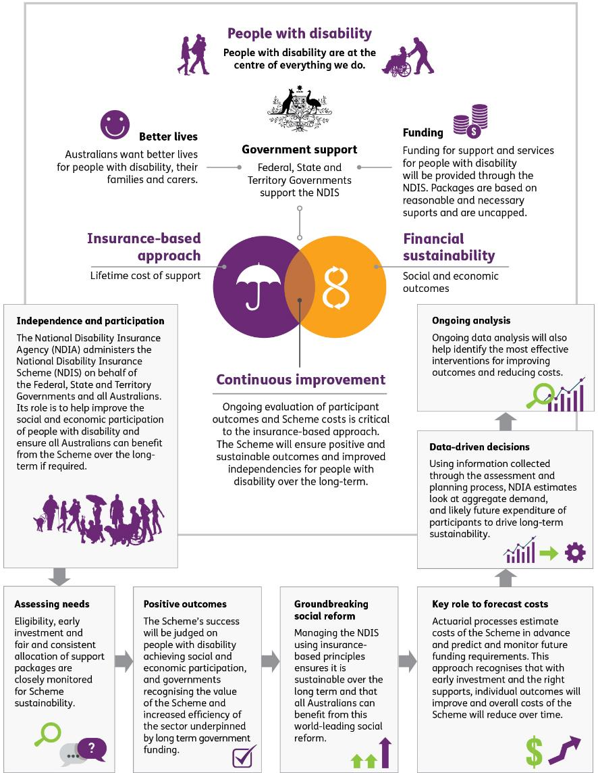

3 NDIA’s Market Stewardship Functions
Market stewardship recognises that when governments implement public/social policies to increase user choice, and adopt market-based delivery, they must also oversee the creation of these markets. Where markets are not working as intended, a responsible market steward identifies what action, if any, it should take to improve the marketplace so policy objectives are realised.
The NDIA will be actively involved in the market stewardship of the NDIS, but it will do so in collaboration with key stakeholders and on both the ‘supply’ and ‘demand’ sides of the marketplace. There will be a need for active market stewardship and market design in the short to medium term as the NDIS is rolled out through the transition phase.
The diagram below illustrates the NDIA view of market success for both the participants and providers in the NDIS marketplace. It has also detailed the components of the market environment which will enable the market to function effectively.
Diagram 7: Measuring success by participants and providers
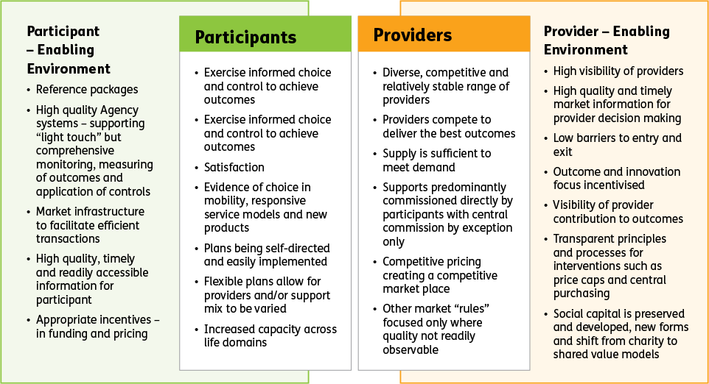

3.1 NDIS Market Stewardship Transition Roles and Responsibilities
The Agency is committed to a market stewardship approach that takes into account factors such as do no harm, take a holistic approach with respect to the impact of innovation, preserve and build social capital, offer choice and control (widely defined), strive to democratise data, work across mainstream systems, and utilise intervention mechanisms only where necessary and where a clear exit strategy exists.
The specific roles and responsibilities of the NDIA and examples of actions linked to each are listed in the sections below. This framework illustrates the key stewardship functions which the Agency will use to guide the NDIS market as it develops over the transition period. At a practical level specific protocols and initiatives during transition are the subject of NDIS Market and Sector Working Arrangements being negotiated with each jurisdiction.
The NDIA’s ‘market stewardship’ function is a shared responsibility, in accordance with the Integrated Market, Sector and Workforce Strategy, the NDIS Act, and the roles and responsibilities agreed with jurisdictions and the Disability Reform Council (DRC). These responsibilities will evolve over time and are likely to change once the NDIS is fully deployed and as the National Quality and Safeguarding Framework is implemented. The responsibilities outlined in this market approach are therefore focused on NDIS transition (2016-2019).

Roles and responsibilities in market stewardship and oversight
During transition, the market stewardship role of the Agency will be more active; to facilitate development of the marketplace and as a catalyst for basic market infrastructure. This includes information provision, setting prices and pricing policy, demand signalling and supporting development of a vibrant market of suppliers operating competitively and innovative practices.
Activity 1. Market Oversight – Policy, Regulation and Strategy
The NDIS marketplace will require formal oversight and regulatory functions including appropriate safeguards and market protections. During transition, states and territories will continue to lead the delivery of existing quality and safeguards frameworks. Consistent with the NDIS Act and with the instructions of the NDIA Board, the Agency will continue to set aims, objectives and goals relating to the effective operations of the Scheme.
This is led by COAG and DSS who determine the high-level NDIS policy, proactively monitor, review and report on the effectiveness of the NDIS and provide guidance for implementing policy, priorities / roles and approach and coordination of issues jurisdictions and sectors.
Activity 2. Monitoring
The NDIA must monitor whether markets are working, adapting, and innovating as expected; and whether policy goals are being achieved. This will happen through the collection of a broad range of formal NDIS data, independent information sources, and anecdotal information from on-ground sources.
The market monitoring regime builds a body of information on the NDIS marketplace, its operation, and whether it is delivering the intended outcome. The monitoring systems should support market intervention, where necessary, by collecting the information that the NDIA needs to:
fill in information gaps that occur because of the special features of disability markets;
administer and enforce price regulation of the market;
identify and respond to emerging and anticipated issues; and
manage relationships.
Monitoring may also include assessments of key markets to help providers, as well as participants and service intermediaries, such as plan management, and support co-ordination agencies to understand the developing local markets they operate in. This will allow them to make informed decisions now and identify challenges and opportunities for the future. Assessments also allow the Agency to understand any barriers (actual or perceived) to providers entering or expanding in the market.
This is the role of NDIA and DSS.
Activity 3. Market Intervention Strategy
Monitoring will identify anomalies in various segments of the marketplace, whether in a geographic location, particular sub-market, or an entire support service. The Agency will be particularly focused on anomalies which highlight problems with performance or risks to the goals of the Scheme. In these cases, the response to ‘correct the market’ will be in the form of ‘market interventions’. The strength of the response will take into account the risk posed to the safety of participants, health of the marketplace, or sustainability of the NDIS. Decision making will use comprehensive data to ensure decisions are evidence based and more targeted.
Further discussion about the features of the Market Commissioning Strategy is discussed in Section 3.2.
Market Intervention Strategy – Facilitation
Function: Information provision
Role: NDIA
Description: Producing and publishing of resources to inform actions of participants and providers
Function: Benchmarking
Role: NDIA
Description: Capturing and publishing data on efficient service delivery, best practice models, outcomes, consumer satisfaction etc.
Function: Market Infrastructure
Role: NDIA
Description: Facilitating supply and demand, matching and transactions through eMarkets, smart markets, and exchanges.
Function: Quality / Training
Role: NDIA, DSS, States and Territories*
Description: Developing measurements of and/or facilitating exchange of info about provider quality and developing quality frameworks
Function: Terms of Business
Role: NDIA
Description: General regulations for businesses and NDIS-specific regulations imposed by NDIA
Function: Pricing and controls
Role: NDIA
Description: Determining efficient prices for supports. Setting price caps and other price and budgetary controls where necessary
Market Intervention Strategy – Commissioning
Function: Commission a service
Role: NDIA
Description: Agency directed commissioning of supports rather than participant directed.
Function: Direct purchasing
Role: NDIA
Description: Agency direct procurement, for example, to establish a Provider of last resort (PoLR).
Market Intervention Strategy – Capacity Building
Function: Consumer / community capacity
Role: NDIA
Description: Guidance and functions (e.g. ILC, LAC) to improve participant knowledge/empowerment
Function: Plans and plan implementation
Role: NDIA
Description: Supporting participant goals and funded and mainstream supports to achieve these goals
Activity 4. Evaluation
Review the market-interventions; assess their success, and re-evaluate the market issue. Consistent with NDIA’s mantra of ‘Listen, Learn, and Build’ and also conventional performance improvement cycles; all actions, or in this case market interventions, need to be effectively evaluated to determine if, and how, they performed against their stated objective. In the case where the market interventions did not work, an analysis needs to determine if the strategy or/and the governing variables for that strategy were correct. The evaluation criteria should ideally be determined, and stated, at the time the market interventions are chosen. Knowledge gained, both good and bad; will help improve our responses to future, similar issues and to progressively strengthen the marketplace.
This is the role of NDIA and DSS.

3.2 NDIA Market Approaches: Market Intervention Strategy
Market interventions are a key aspect of all regulated/semi-regulated markets, especially where there is a public interest and has significant government ownership. The NDIA will have a starting point, with respect to market-interventions, of as minimal interference as possible in the market. Any market interventions must protect the interests of all parties within the NDIS and wider community and maintain the integrity in the marketplace.
Providers and/or participants will be a key source of early awareness and notifications of issues with a particular market or sector and thus will be key partner to determining a practical solution.
Market interventions operate within the parameters of the high-level ‘goals’ and ‘rules’ and legislation, as discussed earlier and within the budgetary controls and rules of participants individual ‘plans’.

Market commissioning principles
There are four key considerations the Agency will be guided by in decision making on market-interventions to address trending or actual deficiencies in the NDIS marketplace.

Non-distortionary or minimalist
The market interventions should ideally be non-distortionary (minimalist) in their application in achieving the desired outcome. Market-interventions will be operationalised by ‘actions’ by the NDIA, and these actions should:
aim to ensure no interruption to service support for participants;
maintain, as best as possible, choice and control for participants;
be targeted or temporary, with identified exit timeframes and strategy;
have triggers for ratcheting of actions and assessing effectiveness;
be balanced and the benefits from intervening outweigh the risks;
be ‘market neutral’, in that the Actions do not favour the incumbent over new entrants or vice versa or specific individual providers over others; and
be transparent and communicated to the market.

Assessment of ‘Impact’
The market interventions should assess the ‘net gain’ to the marketplace including consideration of:
Will the increase to service/product value and/or reduction in risk be outweighed by the cost to the Scheme (in terms of negatively altering the market or not fulfilling to goals of the Scheme)?;
How the ‘costs’ and ‘benefits’ will be distributed?; i.e. will they be fairly distributed or will they be unfairly concentrated in a particular segment of the market; and
Are the changes sustainable?

Social Capital
“Social capital relates to the social norms, networks and trust that facilitate cooperation within or between groups. It can generate benefits to the whole community by reducing transaction costs, promoting cooperative behaviour, diffusing knowledge and innovations, and through enhancements to personal wellbeing and associated spill overs”.
The Agency’s Information, Linkages and Capacity Building (ILC) activities will build on existing social capital in the sector. Voluntary links between the community and people with disabilities to stimulate ‘social capital’ is an important outcome for the NDIS, with a goal to increase, rather than crowd out existing formal and informal arrangements.
Agency decision making of market interventions will consider the potential impact on social capital in terms of the risks to, and importance of, maintaining and developing social capital and capacity building including new forms of social capital such as impact investing.

Addressing specific provider failure – provider of last resort
The rationale for market stewardship is to maintain a healthy, balanced, and sustainable marketplace and to avoid ‘market failure(s)’. The NDIA may identify a ‘weakening’ or ‘thinning’ of provider choice in specific sub-markets, either in a geographic location or in a support item more generally, or corporate failure of an individual provider that would create significant market risk. For example, if the only local provider for a range of disability support services in a remote community goes into administration; the identification and response to market failure is a collaborative effort between all relevant NDIS stakeholders.
Diagram 8: Continuum of NDIS market intervention options
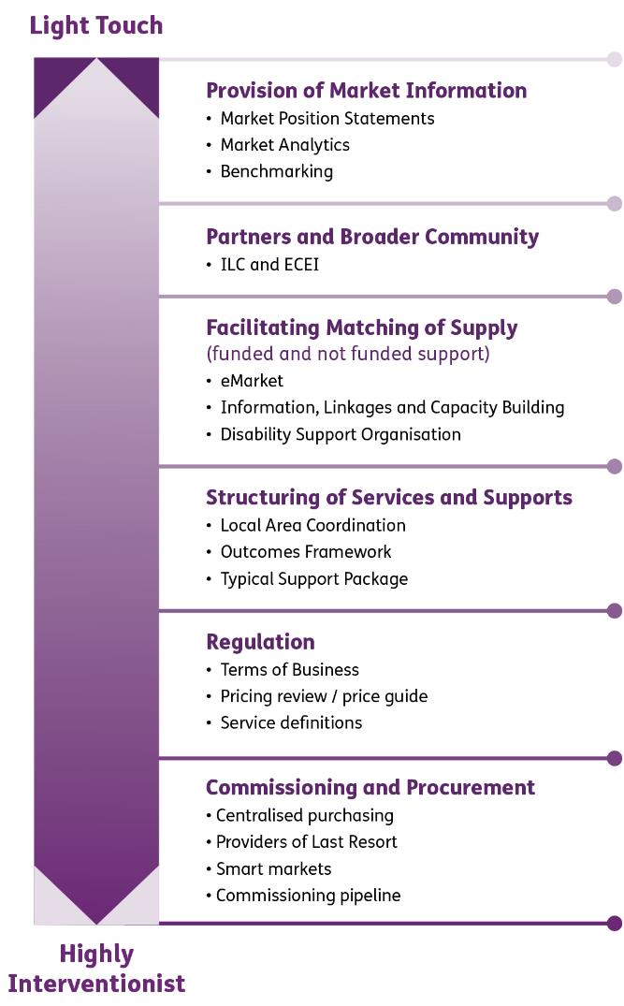

Market intervention options
There are a suite of different options or levers which the NDIA is seeking to use to develop and correct the NDIS marketplace. Whilst likely more interventionist in the short term, these levers sit on a continuum and range from ‘light touch’ actions, such as the simple provision of information for market participants and/or providers which is not being delivered by the market, to more specific application of defined standards and quality controls, and more ‘heavy touch’ actions such as reviewing/setting price controls, stopping a service or direct purchasing of services.
These options can be classified as follows.

Information
Access to accurate, timely, and relevant information is vital in any decision making. In the NDIS context, the NDIA wants participants to have easy access to all possible information about Scheme entitlements, but importantly also about all possible service providers from which they can choose. Existing providers need information to invest in growth and adapt their service offerings whilst new provider entrants will want information to provide confidence to invest in the marketplace.
The NDIA will be mindful of ‘information overloads’ and crowding out private solutions. Information which the NDIA produces as part of a market interventions will need to be in an easily accessible form and publicly available to counter any perception of advantage in the marketplace.
The NDIA as a market steward cannot share market information inequitably, or favour particular providers unintentionally.
Examples of information which will assist in improving the NDIS marketplace:
Market Position Statements (MPS) – to inform market stakeholders and help current and prospective providers to prepare for the opportunities. MPSs allow providers to better understand areas of expected demand growth and the characteristics of particular markets around Australia. The MPS’s are expected to evolve based on feedback from the market and become more detailed over time.
eMarketplace – will bring together participants and providers and be a constructive source of information to allow choice and control by participants. The initial release will include transactional capabilities and ensure that the NDIA has the data it needs to ensure effective actuarial monitoring of the Scheme’s performance and compliance with the Agency’s risk management framework. Work is already underway to co-design key elements of this capability - including “virtual wallet” products and interfaces with financial intermediaries. In parallel, the Agency is also working on developing its own, and facilitating others’ online information-eMarkets on services and supports available to participants which are needed to provide accessible and useful information about choice and availability.
Market Analytics – In accordance with section 174 of the Act, the NDIA is producing Quarterly Reports, including market dashboards. These reports and dashboards provide market analytics and information (including statistics) about participants in each jurisdiction and the funding or provision of supports by the NDIA in each jurisdiction.
Benchmarking – of service and organisational costs will provide information to support the development of a vibrant, responsive and sustainable market.
Providers are encouraged to undertake their own extensive market research before making strategic decisions about investing or changing their services in response to the NDIS.

eMarketplace as a means of facilitating competition and monitoring the market
The NDIS wants a vibrant marketplace, and will intercede into the market to facilitate interactions between participants and providers with minimal search effort and transaction costs by providing an ‘eMarketplace’ platform. By providing such a platform, the NDIA hopes to minimise transaction costs, reduce barriers to entry and lower operating costs for all providers and to establish a business environment which allows a full spectrum of business types to exist. The eMarketplace is under development, and will act in a way similar to a ‘retail shopping complex’ rather than an actual retailer in its own right. Providers will have interfaces, similar to ‘shop fronts’ in this ‘shopping complex’, and can market their products and services through this mechanism. Co-design and clear communication with providers will be key principles adopted in the development of the eMarketplace. It should be noted that participants are not bound to this eMarketplace and can search and procure services in their own way and using other marketplaces.
Importantly the eMarketplace is also a key pillar in the NDIA’s ability to facilitate price competition and monitor supply, providing timely data and analytics that would be more detailed than available in participant plans.

Consumer and Community Capacity Building
The NDIA will also intervene in the marketplace via initiatives which strengthen the capacity and capability of communities and participants. In the early and transition years a number of ‘supports’ or capacity building initiatives have already been introduced primarily for participants. These initiatives are detailed in the Information, Linkages and Capacity Building Commissioning Framework and include:
Information, Linkages and Capacity Building (ILC) – the ILC program builds the capacity of people with disability, the community, their families and carers by providing the right information and skills.
Local Area Coordination (LAC) - Local Area Coordination (LAC) assists people with disability to be included in their communities (including informal networks, community groups, disability and mainstream services). This support aims to encourage the transition from the traditional centralised model of program delivery by bringing support to participants on the ground, in their own communities.
Outcomes Framework - The Outcomes Framework was developed to measure the medium and long-term benefits of the Scheme for participants and their families. Individual results can be aggregated which enables the NDIA to provide a picture of how and where the Scheme is making a difference overall. Data from the framework also enables modelling to uncover the factors and supports that predict progress towards the achievement of outcomes.
Typical Support Package (TSP) – TSPs aim to provide an annual benchmark funding level of support for participants with similar support needs and characteristics. TSPs assist the NDIA with monitoring the financial sustainability of the Scheme.

Terms of business and interacting with the agency as a registered provider
One of the foundation functions of market-stewardship of the NDIS will be setting the ‘Rules’ to entry and continued participation in the Scheme. In the context of the NDIS market stewardship and market-interventions, ‘regulations’ means the operational terms, system rules, and standards which providers need to agree and adhere to. This is distinct to the (big ‘R’) ‘Regulations’ which will set and managed outside of the NDIA and be encapsulated in the implementation of the National Quality and Safeguarding Framework being developed by the DSS in conjunction with the NDIA and states and territories. Operational guidelines, safeguards, and other rules help protect market viability and the long term interests of both participants and providers. Administering these arrangements is on-going market stewardship role and the enforcement will be a market-intervention activity. Some of the existing regulations include:
Terms of business - Terms of Business establish protocols and processes that are binding on a Registered Provider of supports in the NDIS. The Terms of Business ensure that providers agree to uphold the objectives of the NDIS and work with participants to achieve individual outcomes. At this stage the NDIA is deliberately non-prescriptive regarding specific expectations about “how” providers should comply with some key elements of the Terms of Business, including management of conflict of interest, format and terms of service level agreements, record keeping etc. However, in response to feedback that guidance on these would be helpful, especially where expectations and requirements might be introduced, the NDIA is committed to working with industry leadership to develop clear guidance and best-practice examples for these important processes.
Pricing reviews / Price Guide - The setting and reviewing of NDIS prices is a significant market-intervention initiative. Whilst the NDIA will update prices on at least an annual basis effective 1 July each year, taking account of market trends, changes in costs and wage rates, for most submarkets it sees this as a temporary measure to support the marketplace. In the long-term, the NDIA will not set prices to the extent it does now and will instead allow the marketplace to determine the price of supports. Already in parts of the NDIS market, self-managing participants, as empowered consumers, are seeking value for money – which is driving competitive pricing, greater flexibility and a quality workforce.
Provider Assurance Teams - a Provider Assurance Program has been established to test provider’s adherence to NDIA Terms of Business and rules to ensure that claims are documented and can be substantiated. To give greater clarity and transparency to the process, the NDIA has developed good practice documentation guidelines and anticipates distribution to providers in the near future.

Commissioning a service
One of the most significant risks during transition is the potential gap between supply and demand and more specifically, the lack of both providers and disability staff in specific locations. Given they too will continue to operate in the market during transition, and have to-date managed this risk, state/territory governments will remain a key partner for determining appropriate strategies. However, it is clear that post-transition, many States and Territories have signalled an intent to withdraw as direct service providers which may create different supply gaps.
Where a particular issue is either significant or unusual enough the NDIA will, in a very small number of cases commission a time-limited solution with a clear exit strategy. The trigger for commissioning or other more direct intervention in the NDIS marketplace by the Agency will drive the nature of the response. Triggers are likely to include:
Insufficient, volatile or uneven supply – in a particular geography, market segment or service type potentially due to lack of scale or providers being active in that market;
evidence of inappropriate use of market power – for example constraints to competition or lack of consumers exercising choice;
insufficient quality at a reasonable price;
benefits for greater return on investment from arrangements other than individual commissioning.
This commissioning will involve key stakeholders in the marketplace who possess vital information and/or influence in the solution. Market commissioning activities include:
Commissioning where economies of scale and/or where Commonwealth purchasing power can be leveraged without causing harm or damage to a market, for example in the bulk purchasing of AT products;
Providers of last resort - Providers of last resort (POLR) is where the Agency directly commissions the provision of goods and services in order to ensure supply. An organisation engaged under POLR arrangements will need to meet agreed quality standards and will be required to engage with the individual, family and community to ensure that delivery of services is done in an appropriate and culturally competent way;
Merit Goods – Merit goods are those which produce benefits that would be under consumed or undersupplied if left to market and consumer preferences; and
Commissioning pipeline – A commissioning pipeline will be developed and regularly maintained. It presents a forward view of known upcoming market sourcing activity. The pipeline will be made available in the public domain to enable suppliers of products and services to better plan and prepare for future scheduled market initiatives.

4 Next Steps – Navigating growth to full Scheme
This statement provides market signalling for the way NDIA will inform and guide the development of the NDIS. In the coming years, through the ‘transition phase’ to full Scheme market stewardship activities will be operationalised the activities described in this Market Approach which the NDIA will lead across Australia.
The NDIA is currently developing Market Working Arrangements with states and territories for Market and Provider readiness. These working arrangements align monitoring, market development, workforce development, and actions required to address vulnerable sub-markets with existing protocols and systems currently in place in each state and territory.
The following sections outline current and forecast future activities and timeline for NDIA market stewardship activities which are aimed at facilitating the development of the NDIS marketplace during the transition to full Scheme.
Note that the forward work-plan remains subject to change and is dependent in some cases upon successful delivery of projects in previous years, a shared understanding with providers and experiences during transition as the Scheme expands. Market intelligence or specific issues not yet identified will necessarily change this work plan which the NDIA will update as future market approaches are published.

4.1 2016-17 Forecast Market Stewardship activities and projects

What does the market look like?
High market growth of approximately eight per cent, reflecting the initial focus of moving existing service users into the Scheme.
Much more rapid Scheme growth than during trial; with an additional 87,000 (26 per cent of total) participants joining the Scheme in the first year, compared to 30,000 across the full trial.
NDIA processes and systems adjusted to reflect the need to scale rapidly as part of full Scheme launch (from those used during trial) including the new Portal and Provider and Participant Pathway.
Some jurisdictions commencing exit of direct service delivery (as providers) under the NDIS, with these services now being delivered by other organisations as the NDIS rolls out.
Initial market entry from digital disruptors, first movers and niche providers seeking to establish themselves in the NDIS marketplace prior to the Scheme achieving scale. Some achieving rapid growth. Large numbers of allied health professionals registering as providers.

What Stewardship Activity will the NDIA do?
Information:
Release of Market Position Statements highlighting growth opportunities at a regional level within each jurisdiction. Six MPS’s have been released to date with the MPS for NT currently in development.
Implementation of the first iteration of the NDIS Provider Benchmarking via co-design of an initial survey and metrics.
Further updates to improve useability of existing provider information resources such as the Provider Toolkit, Catalogue of Supports, Price Guide and Guide to Suitability.
Agree with each jurisdiction, Market and Sector Working Arrangements and sharing information as these are negotiated and finalised.
Facilitation:
Development of the Terms of Business for registration, which included specific provisions relating to market stewardship such as prohibition of commissions, and other market related rules.
Support Coordination already expanded to provide greater support for capacity building for self-managed participants and an increase in the Financial Intermediary monthly processing fee to $96.63.
2016-17 (launch) pricing announced which extended transition pricing for core supports. This included a 3.9 per cent increase in prices applied for Personal Care and Community Participation supports.
Additionally price loadings increased to 18 per cent for remote areas and 23 per cent for very remote service delivery.
The price review (for 2017-18 prices) to be published in Q2 2017 will focus in particular on supported independent living and related supports.
In conjunction with DSS, development of initial market monitoring frameworks, based on early launch data, to assist in monitoring for supply gaps and weak or thin markets by June 2017.
Development of an interim AT sourcing strategy, responding to evidence of predatory pricing whilst allowing participant choice including purchase of AT more costly than the reasonable and necessary level funded under the NDIS.
Refinements to Quality and Safeguards arrangements during transition that have been agreed in bilateral Working Arrangements.
Development of policies and rules relating to conflict of interests in particular support categories.
Development of NDIS eMarketplace.
Commissioning and Capacity Building:
Smart Markets Transport project as a pilot for specific transport services where individualised commissioning may lead to suboptimal outcomes.
Agree to Provider of Last Resort processes, in conjunction with jurisdictions, to address market level failures.
Operationalisation of Specialist Disability Accommodation (SDA) supports, (last resort) vacancy management, dwelling registration and SDA rules.
Initiation of School Leaver Employment supports.
First procurement in numerous launch jurisdictions, of Partners in the Community.
Clarification of provisions for Early Childhood Intervention Services.
Additional commissioning projects, research and pilot projects for markets including Transport and Rural and Remote.

4.2 2017-18 Forecast Market Stewardship activities and projects

What does the market look like?
Significant market growth of approximately 40 per cent, reflecting bilateral targets for participants entering the Scheme.
Rapid expansion of the NDIS with the Scheme bringing in a further 143,000 participants, reaching a total of 260,000 (57% per cent of full Scheme) by July 2018.
Significant expansion in the need for intermediary and other community capacity building functions reflecting larger numbers of plans being created and managed outside of the NDIA.
Ongoing market activity including consolidation and partnerships between providers. Visible market entry from providers in adjacent markets who have not previously delivered disability services and supports and horizontal integration with providers delivering other (non-disability specific) services in the market such as health, age-care, insurance and financial services.
NSW will complete NDIS rollout for existing and some new participants, and will represent approximately 1/3rd of the full Scheme NDIS.

What Stewardship Activity will the NDIA do?
Information:
Market position statements for specific market segments likely to include housing, transport and/or assistive technology. Further information published relating to jurisdictions as additional market data such as utilisation becomes available.
Implementation of the annual provider benchmarking, including publication of reports and the ability for providers to compare market benchmarks against their individual data.
Sharing information through agreed Market and Sector Working Arrangements.
Additional information projects deployed via regional engagement teams in each jurisdiction.
Publication of data related to initial market monitoring activities from the eMarket and other data sources.
Establishment of regular communication through newsletters and other channels.
Facilitation:
Pilot of solution options for rural and remote service delivery, in conjunction with DSS, states and territories.
- Other market focused projects that will assist transition of the market as a whole. Focus areas likely to include:
- participant employment;
- SDA supply;
- provider working capital;
- consumer feedback on provider experiences, and matching of supply and demand; and
piloting strategies for enabling competitive submarkets, including increasing competitive pricing for specific services, based on experiences of supply for quotable items and within already deregulated markets such as self-managed participants.
These focus areas will be updated based on market strategy and provider and consumer feedback as the Scheme expands.
Publication of the annual Price Review decisions including implementation of a repeatable process that will publish price amendments (if any) in April / May of each year. Updating of the forward work plan for focus areas of future price reviews, published as part of the annual Price Guide. Price control strategies likely to include a focus on incentivising price competition.
(First) annual provider benchmarking.
Development of NDIS eMarketplace.
Commissioning and Capacity Building:
Refinement of the Assistive Technology strategy if required.
Ongoing expansion of NDIS Partners in the Community, reflecting the growth in required capacity to complete first plans and plan reviews in each jurisdiction.
Initiation of targeted projects to respond too weak or thin submarkets identified during the first year of full Scheme.

4.3 2018-19 Forecast Market Stewardship activities and project

What does the market look like?
Continued significant market growth of approximately 30 per cent, reflecting jurisdictions and the NDIA finalising the full Scheme roll-out across Australia.
Ongoing rapid expansion of the NDIS with the Scheme bringing in a further 178,000 participants, reaching 438,000 by July 2019 (96% of Full Scheme) assuming all bilateral agreements are signed.
Greater maturity in the Agency’s market facilitation and monitoring activities, including participant outcomes and market activity via the eMarket ecosystem.
Ongoing focus on deregulation opportunities within the Agency’s market stewardship function in line with increased competition and consumer-defined choices.
Established providers and new entrants across the range of entity types with some providers gaining a larger market share than the current 2-3 per cent held by the largest providers in the market.

What Stewardship Activity will the NDIA do?
Information:
Publication of more detailed market analytics based on data captured from the first two years of full Scheme which is not currently possible for inclusion in market position statement deliverables, this information will also rely on data from provider benchmarking and other sources where appropriate.
Continuing the annual provider benchmarking, including publication of independent benchmarking reports.
Regional engagement teams leading day-to-day relationships and provision of market information for providers in their jurisdictions.
Ongoing publication of data related from NDIA market monitoring activities including market gaps and opportunities.
Facilitation:
Implementation of specific solution options for rural and remote service delivery, relevant for individual jurisdictions and contexts and in conjunction with states and territories.
Annual Price Review decisions in April / May of each year. Ongoing annual provider benchmarking.
Commissioning and Capacity Building:
NDIS Partners in the Community reaching full scale, by this time some 60 per cent of participant plans are expected to be generated outside of the agency.
Ongoing targeted projects to respond to weak or thin submarkets identified during the second year of full Scheme, with potential for exit of the agency from submarkets where initial interventionist activities were successful.
Maturity of NDIA provider of last resort capabilities, to potentially include a range of response options, such as panels in relevant jurisdictions or submarkets capable of providing emergency capabilities at extremely short notice.

Assuming all bilateral agreements are signed.
The three years of transition are 2016-17, 2017-18 and 2018-19
As noted under the ILC Policy Framework (p. 7) (https://www.ndis.gov.au/community/information-linkages-and-capacity-building-ilc#ilc-policy-framework): “The NDIS Scheme Actuary advises that of Australia’s population of people with disability, there are approximately: - 2.5 million people with disability in Australia under the age of 65 years - 900,000 of the 2.5 million report they need assistance with activities of daily living at least weekly - 410,000 of this 900,000 are likely to access the NDIS as participants”
Refer to the Market Position Statements on the NDIS website.
Sourced from the Parliament of Australia
Gash, T.,Panchamia, N., Sims, S, and Hotson, L. 2013, Making public service markets work: Professionalising government’s approach to commissioning and market stewardship, Institute for Government.
Harper Review (March 2015)
Productivity Commission 2011, Disability Care and Support, Report no. 54 (Volume 1), Canberra, page 207
Currently, States and Territories lead this role and will continue to do so for providers that they fund during transition. Over time, the Agency will lead an integrated response jointly with States and Territories as transition leads to full scheme (noting that under Schedule K of the Bilateral Agreement between the Commonwealth and the Northern Territory, the NDIA is the responsible entity for ensuring provider of last resort services are in place for all participants in the NT.

